Producer Report 3 for B-tree Visualization Project

Director: Samuel Morrison

Producer: Brayden Peck

Other team members: Conley O'Neill, Thomas Wood

# Section 1 Current Tasks

Tasks for this period.

|  |  |  |  |  |  |
| --- | --- | --- | --- | --- | --- |
| Task | Complete/Incomplete | Assigned to | Start Date | Time spent (total) | Comments |
| 1)  Recode existing code in C++ | Incomplete | All | 9/2 | ~40 | This part took much longer than expected to get the b tree classes working in C++ |
| 1.1)  Complete B Tree Data Structure | Complete | Brayden | 9/2 |  | Waiting on the B tree methods to be completed |
| 1.1.1)  Search method B tree | Complete | Brayden | 9/2 | 1 | This method is complete |
| 1.1.2)  Insert method B tree | Complete | Brayden | 9/2 | 10 | This method is complete |
| 1.1.3)  Delete method B tree | Complete | Brayden | 9/2 | 2 | This method is complete |
| 1.2)  Complete B+ Tree Data Structure | Complete | Samuel | 9/2 | ~23 | This data structure is completed |
| 1.2.1)  Search method B+ tree | Complete | Samuel | 9/2 | 1 | This method is completed |
| 1.2.2)  Delete method B+ tree | Complete | Samuel | 9/2 | 15 | This method is completed |
| 1.4)  Link to GUI Backend | Complete | Conley, Thomas | 10/11 | 4.5 | This is complete |
| 1.5) Display Data structures | Incomplete | Conley, Thomas | 10/11 | ~18 |  |
| 1.5.1)  Insert Cells | Incomplete | Conley, Thomas | 10/11 | ~16 | Still working on getting cells to insert without overlaps. We have been working on getting the |
| 1.5.1.3)  Layout Cells | Incomplete | Conley, Thomas | 10/11 | 8 | Working on getting cells inserted without overlap |
| 1.5.1.4)  Add arrows to cells | Incomplete | Thomas | 10/20 | 7 | Working on finish up highlighting arrows. |
| 1.5.2)  Animate Actions | Incomplete | Conley, Thomas | 10/11 | 13 | Still working on animations |

# Section 2 Completed Tasks

Completed tasks:

|  |  |  |  |  |
| --- | --- | --- | --- | --- |
| Task | Assigned to | Estimated completion time | Actual completion time | Start Date |
| 1.1 Complete B Tree Data Structure | Brayden | 5 | .5 | 9/2 |
| 1.1.1 Search Method B tree | Brayden | 5 | 10 | 9/2 |
| 1.1.2 insert method B tree | Brayden | 5 | 4 | 9/2 |
| 1.4 Link to GUI Backend | Conley, Thomas | 2 | 5 | 10/11 |

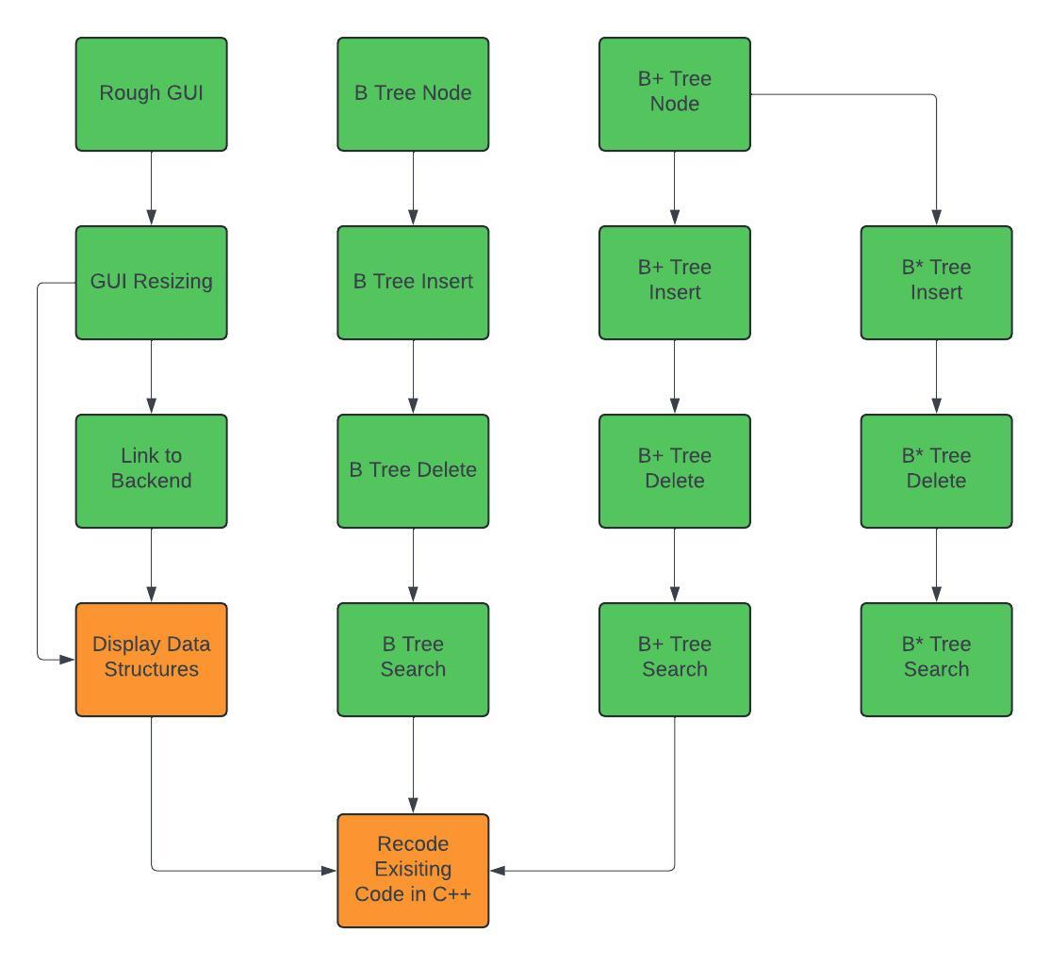

Meeting schedule

|  |  |  |
| --- | --- | --- |
| Date | Time | Attendance |
| 11/1 | 8:00 am – 8:50am | All |
| 11/4 | 8:00 am – 8:50am | All |
| 11/6 | 8:00 am – 8:50am | All |
| 11/8 | 8:00 am – 8:50am | All |
| 11/11 | 8:00 am – 8:50am | All |
| 11/13 | 8:00 am – 8:50am | All |
| 11/15 | 8:00 am – 8:50am | Brayden, Samuel, Thomas |
| 11/18 | 8:00 am – 8:50am | Brayden, Samuel, Conley |
| 11/20 | 8:00 am – 8:50am | Brayden, Samuel |

# Section 3 Incomplete Tasks

1) recode existing codebase

1.5) Display data structures(incomplete)

1.5.1) insert cells (incomplete)

1.5.1.3) Layout cells(incomplete)

1.5.1.4) draw arrows(incomplete)

1.5.2) Animate Actions(incomplete)

# Section 4 Upcoming Tasks

Upcoming / Incomplete tasks

|  |  |  |  |
| --- | --- | --- | --- |
| Task | Assigned to | Estimated Time Spent | Estimated Start Date |
| Search method B tree | Brayden | 5 | 9/2 |
| Insert method B tree | Brayden | 5 | 9/2 |
| Delete method B tree | Brayden | 5 | 9/2 |
| Display Data Structures in GUI | Conley, Thomas | 10 | 10/11 |
| Display Data Structures | Conley, Thomas | 10 | 11/1 |
| Draw arrows | Thomas | 7 | 10/20 |
| Animate Actions | Conley, Thomas | 10 | 11/1 |